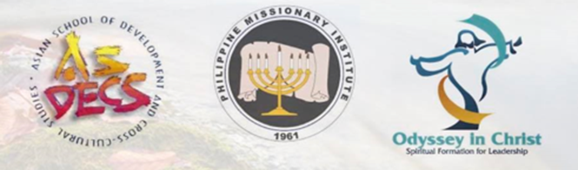

MASTERS IN TRANSFORMATIVE SPIRITUALITY
SAMPLE OF STUDENT TESTIMONIES
2021-22

I’m forever indebted to you and the direction and instruction you’ve given me as I’ve discovered and learned about a more contemplative life the last 2.5 years. I’m so very grateful…..

My heart will always be eternally appreciative to God for this experience. This MTS class benefited, inspired, and transformed me. As a result, I am eager to put my knowledge to use and share my joy…..

When we enrolled and joined in this Master of Arts in Transformative Spirituality course, I thought it is the normal cognitive-based, academic and informative style of learning, but to my great surprise, I felt I am in a family that I had been longing to be with, I found freedom to open-up my heart when I sensed that we are gathering for a conversation that addresses life’s real hunger – GOD.
To all my MTS . . . classmates and friends, I am deeply honored and blessed to meet them coming from various parts of the world. It is so amazing that we are all connected through this journey to learn and grow deeper in Christ. I am inspired whenever they’re sharing, thus I could be able to apply and practice what I’ve listened from them. I pray that we may continue to walk by God’s will, and we may share the experiences we had in this journey with people we meet and know as we minister to them.
I learned in our MTS class that we need a safe space for those who are sharing their life experiences. We must offer them a secure haven where they may feel loved, welcomed, and cared for. Paying attention to others demonstrates our love and regard for them. Like Jesus, He constantly cared for everyone, whether they were sinful or not. Everyone is loved by Jesus. He loves the sinner but not the sin itself.
I [will] never regret that I enrolled in this program instead of pursuing my doctoral degree. I believe that it is part of God’s plan for me to be transformed spiritually so that in His perfect time for me to manage a school I could handle it in a way that will glorify Him.

